UNIT 5
REGULAR VERBS
Look and remember.
Verb + ed → past simple regular verbs.
Ej: visit + ed → visited.
If the verb already ends with an “e”, you only add a d.
Ej: like + d→ liked.
- I watched a film on television.
- You liked the play.
- He visited my granny.
- She discovered a box of treasure.
- It invented a machine.
- We talked to my friend for an hour.
- You helped my mum with dinner.
- They played tennis on holiday.
IRREGULAR VERBS
Go | Went
Become | Became
See | Saw
Write | Wrote
Have | Had
Be | Was/Were

- You went to Scotland yesterday.
- He became a doctor last year.
- She saw the Queen last Saturday.
- It wrote a letter last week.
- We had a holiday last weekend.
- You were happy
TO BE
I was You were He/She/It was
We were You were They were

ERIC THE ENGINE
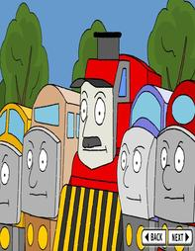
You can find the video in this link:
http://www.youtube.com/watch?v=MM6lFs8SMw8

History:
One day there was a big storm. Lightning struck a mountain
and a huge rock rolled onto the train line.

Seagull saw what happened. He called his friends: Rabbit,
Fox and Mouse. “We must move it. The 10.15 London train
will be here in one hour.” said Rabbit.

The animals tried to move it. They pushed and pushed but it would not move.
“I know,” said Fox, “Let’s get Eric the Engine. He’s stronger than all of us.”

“There’s no time.” said Mouse.
“I’ll get him.” shouted Seagull.

“Help! There is a rock on the train line and the London train is coming very soon.” Eric
tooted his whistle and called his friends. All the engines gathered around.

Eric was big and strong but not very fast. He asked the express trains to go ahead.
“You go first. Then you” said Eric and he sent his friends ahead. “I’ll follow you.”

The engines raced along, but the London train was getting closer.

The trains arrived. The two express trains pushed, but the rock wouldn’t move.

The London train was coming over the hill.

Two more engines arrived and they pushed too. The rock moved a little but the London
train was coming round the corner.

“They can’t do it!” said Mouse.

Then Eric arrived. He tooted his whistle and pushed with all his strength. He pushed the
four engines and the four engines pushed the rock.

Slowly the rock moved. Then it rolled faster and faster until it fell over the cliff.

The London train arrived.
It raced past the engines and the animals, who were waiting on the other line.
The train blew its horn. “Thaaaaank Yooooooou!”
Past simple | Present | Traducción
Saw | See | Ver
Moved | Move | Mover
Asked | Ask | Preguntar
… | … | …

FISH AND CHIPS

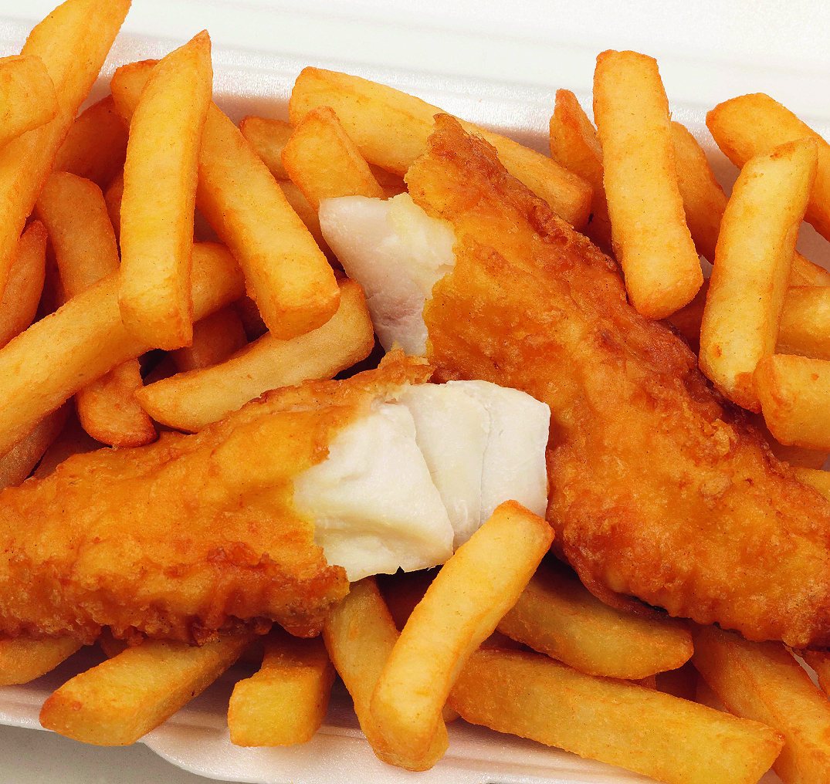

“Fish and chips” is deep-fried fish in batter with deep-fried potatoes, and a popular take-away food. Fish and chips is originally from the United kingdom, but also very popular in Australia, Canada, Ireland, New Zealand, South Africa and some coastal towns of the Netherlands and Norway; and also increasingly so in the United States and elsewhere. For decades it was the dominant (if not the only) take-away food in the United Kingdom.

The fried potatoes are called chips in British and international usage; and while American English calls them French fries, the combination is still called “fish and chips”. Potato chips, an American innovation, are a different potato-derived food, and are known as crisps in the United Kingdom.

Fish and chips have separately been eaten for many years – though the potato was not introduced to Europe until the 17th century. The originally Sephardi dish Pescado frito, or deep-fried fish, came to Netherland and England with the Spanish and Portuguese. Jews in the 17th and 18th centuries.

The dish became popular in more widespread circles in London and the south-east in the middle of the 19th century (Charles Dickens mentions a “fried fish warehouse” in Oliver Twist) whilst in the north of England a trade in deep-fried “chipped” potatoes developed.

It is unclear when and where these two trades were merged to become the fish and chip shop industry we know today. The first combined fish and chip shop was probably the one opened in London by Joseph Malin in 1860.

During World War II, fish and chips were one of the few foods that were not rationed in the UK.

Questions about the text.

- Say True, False or We don’t know.

- Fish and chips are popular only in England.
- Americans call “French fries” what British call crisps.
- Americans call chips what British call crisps.
- The potato was introduced to Europe in the 18th century.
- The dish became popular in the 19th century.
- The first fish and chip shop was opened in the 19th century.
- Fish and chips where not eaten during World War II.

Importante: Además de la información de este Word, también podrán caer en el examen actividades correspondientes a las páginas 42,43 y 44 del libro y 42 y 44 del Activity Book.

